C/C++ SUM OF NUMBERS LAB REPORT

1) Enter your name, student ID, platform (Mac or PC) and date
Name and StudentID: Brian Quintero 0842280
Class: CIS054 C/C++ Programming
Platform (Mac or PC): PC
Date: 2/13/2017

OBJECTIVES:
Use a while loop to input multiple numbers
Use the % (modulo) operator to determine if a number is odd or even
Use variables to accumulate the totals and the average

PROJECT DESCRIPTION:
Write a program that reads in ten whole numbers and then outputs the sum of all the odd numbers, the sum of all the even numbers, and the sum of all numbers, whether even or odd. The user enters the ten numbers just time each and they can be entered in any order. Your program should not ask the user to enter the even and odd numbers separately. You MUST use a loop in this program. Use an integer for input. Note, use value%2 to determine if the number is even or odd. The mod 2 (%2) returns a zero or one depending on whether the number is even (value%2 == 0) or odd (value%2 == 1).
EXTRA CREDIT: 3 points – must be submitted at the same time as the original lab report
In addition to displaying the three sums, display the average of all ten numbers. Since you know that ten numbers were input, the average is the SumOfAllNumbers/10.

INPUTS | PROCESSING | OUTPUTS
Ten numbers | SumOfOddNumbers = 0  SumOfEvenNumbers = 0  SumOfAllNumbers = 0  LoopCount = 0  While LoopCount < 10  Read number from the keyboard  If number is Odd  SumOfOddNumbers += number  SumOfAllNumbers += number  else  SumOfEvenNumbers += number  SumOfAllNumbers += number  LoopCount ++  End Loop  Identify and display all three sums  Compute and display the average (3 points Extra Credit) | SumOddNumbers  SumOfEvenNumbers  SumOfAllNumbers

LAB REPORT:
2) Fill in the TEST VALUES & RESULTS table. Run the program two times with a different set of numbers each time.
TEST DATA VALUES | EXPECTED RESULT  Computed values before  the program is run | ACTUAL RESULT  Fill in the output displayed  by the program
First set of ten numbers  5,9,14,6,3,7,11,8,12,1 | Sum of odd numbers=36  Sum of even numbers=40  Sum of all numbers=76 | Sum of odd numbers=36  Sum of even numbers=40  Sum of all numbers=76
Second set of ten numbers  12,24,16,15,11,1,3,5,9,1 | Sum of odd numbers=45  Sum of even numbers=52  Sum of all numbers=97 | Sum of odd numbers=45  Sum of even numbers=52  Sum of all numbers=97

DISCUSSION:
3) Complete the DISCUSSION section. It does not need to be long, but it needs to be complete.
3a) What did you do to develop the program? ("Followed the Directions" is not a complete description

I figured that I needed three inputs for all the three different types of sums I would have as my outputs.
So I set up my odd , even, and all . I had to read on how to do the while if else and from their it was easy.

3b) What problems did you have and how did you overcome the problems?

I accidentally put the odd in my even outcome and for my first test my results came back as
SumOfOddNumbers=36
SumOfEvenNumbers=36
SumOfAllNumbers=76

I went back and I found my error and just switched odd to even and problem resolved
PROGRAM OUTPUT:
4) Show two screen shots of the program execution.
- Run the program with ten input values
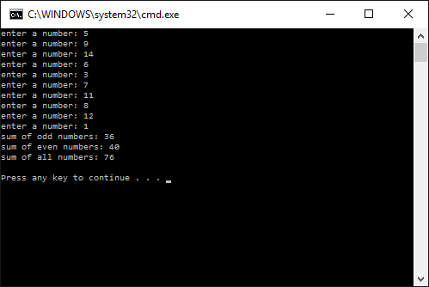
- Run the program with a different set of ten numbers
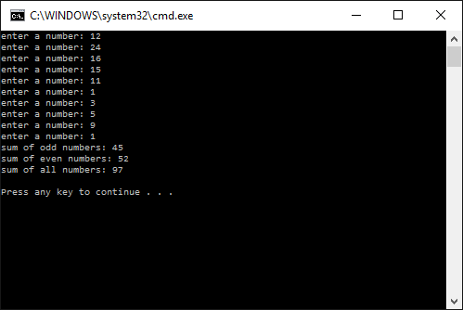

For the Mac, hold down command + shift + control keys and press the 3 key.
Use command+V to paste the clipboard into the lab report.

For Windows, There are two ways you can capture a screen shot of only your program:
- Use Microsoft's Snipping Tool by clicking on the Start icon and selecting "All Programs" then "Accessories". Use the mouse to select the area of the screen you want to save then click Ctrl-C or select the menu items Edit-Copy to save the image to the clipboard.
- Capture the active window to the clipboard by holding down the Alt key and tapping the PrintScreen key. NOTE: some notebook computers require that you hold down a [Fn] key and Alt keys to activate the PrintScreen function. NOTE: Do not click PrintScreen without the Alt key. This would capture the entire screen which would make your program output difficult to see.
Use Ctrl+V to paste the clipboard into the lab report.

PROGRAM LISTING:
5) Copy and paste the code that YOU typed to make the program work. Your program should include a comment block at the top that shows the name of the program, date, version and your name.

// C++SumOfNumbers.cpp

//Inputs:Enter 10 Numbers
//Outputs: sum of odd numbers, even numbers all numbers
//CIS054 C/C++ Programming
//Brian Quintero
//6-24-2016

#include "stdafx.h"
#include <iostream>
using namespace std;

int _tmain(int argc, _TCHAR* argv[])
{
int sumOfOddNumbers = 0;
int sumOfEvenNumbers = 0;
int sumOfAllNumbers = 0;

int number;
int inputcounter = 0;
while (inputcounter < 10) //count from 0 - 9

{
cout << "enter a number: ";
cin >> number;

if (number%2 ==1) //odd number
sumOfOddNumbers += number;

else //even number
sumOfEvenNumbers += number;

//also add the total of all numbers
sumOfAllNumbers +=number;

//keep count of how many numbers were entered
inputcounter++;

}//end of while loop

//display the results
cout << "sum of odd numbers: " << sumOfOddNumbers << endl;
cout << "sum of even numbers: " << sumOfEvenNumbers << endl;
cout << "sum of all numbers: " << sumOfAllNumbers << endl;

cout << endl; //blank line at the end of the program

return 0;
}

